**Updating and configuring Microsoft Windows Defender to scan for threats**

In this project I received instructions on how to update threat definitions before scanning for threats within a virtual machine provided by the course.

**Updating threat definitions**

I first navigated my way to Windows Security Virus and threat protection. To do this I pressed the Windows button at the bottom left corner of the screen before selecting the ‘Settings’ option. After that I chose ‘Update and Security' before selecting ‘Windows security’. Following this I clicked on ‘Virus and threat protection’. In this page I made sure that the threat definitions were up to date so that the computer knows what to look for, including new and recent threats.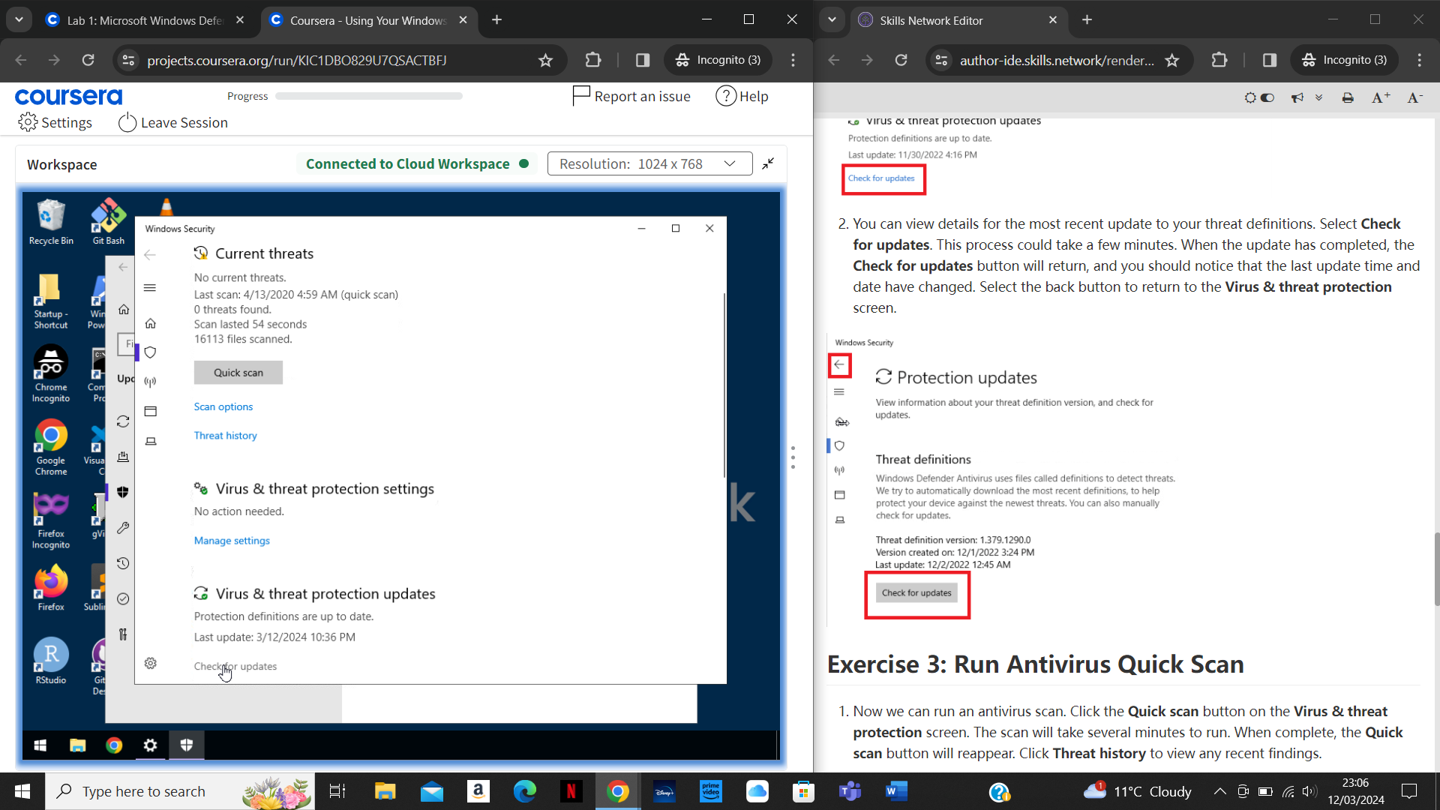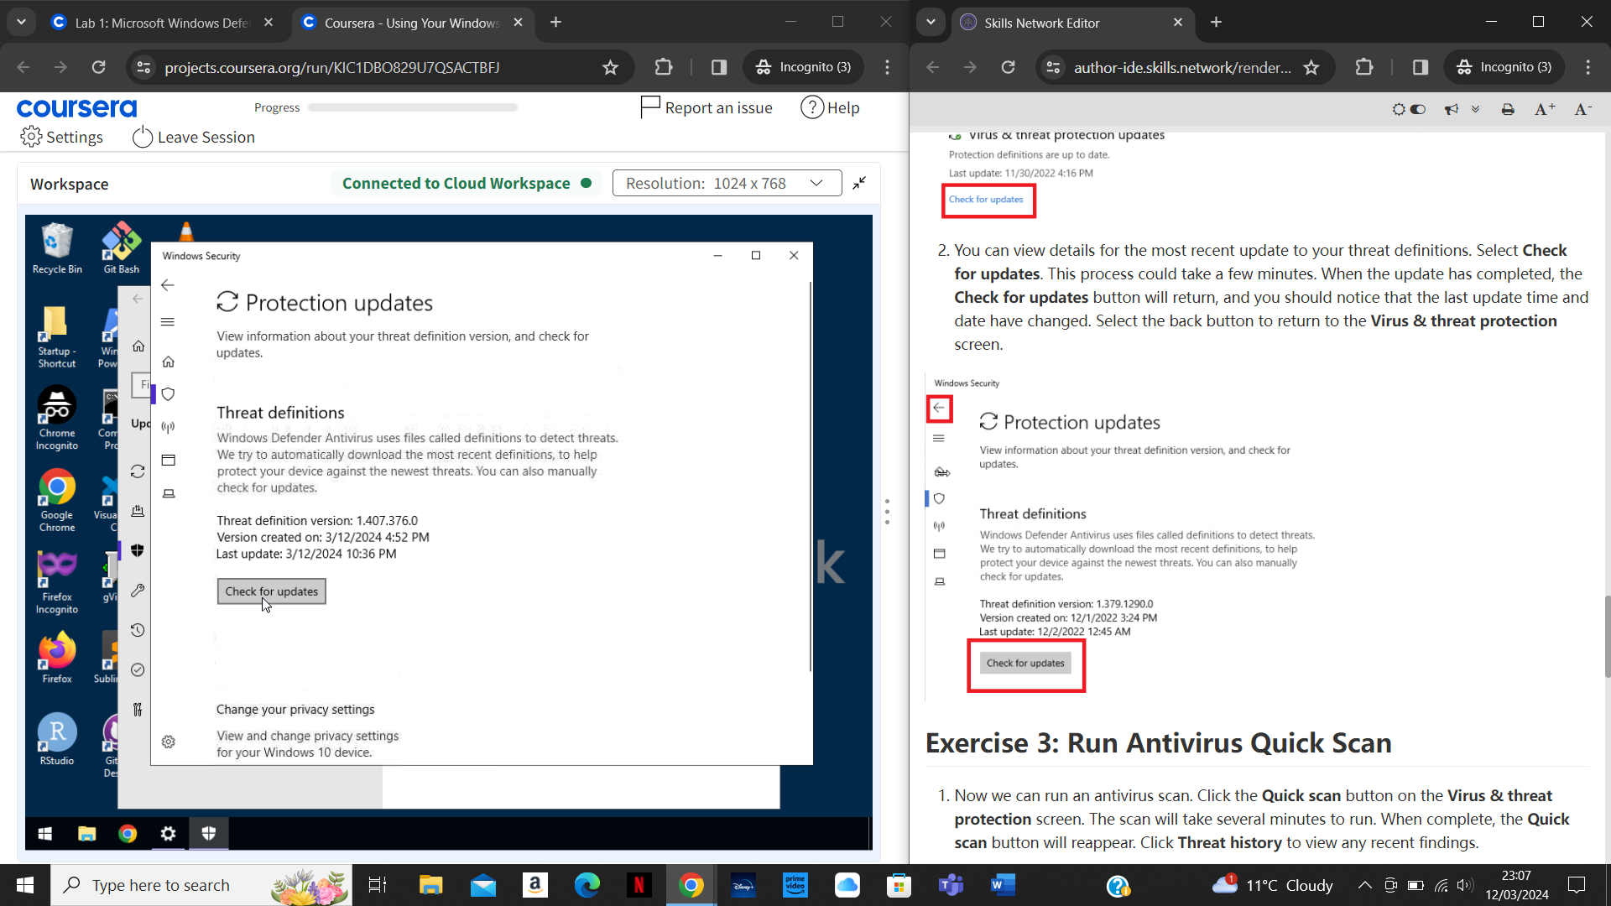

The screenshots above show the Virus and threat protection page. In order to ensure threat definitions are up to date I clicked on ‘Check for updates’ under’ Virus & threat protection updates’. I then clicked ‘Check for updates’ again in the next page under ‘Threat definitions’. The threat definitions have now been updated to the latest version.

**Scanning for threats**

After this, I was now ready to scan my computer for threats.

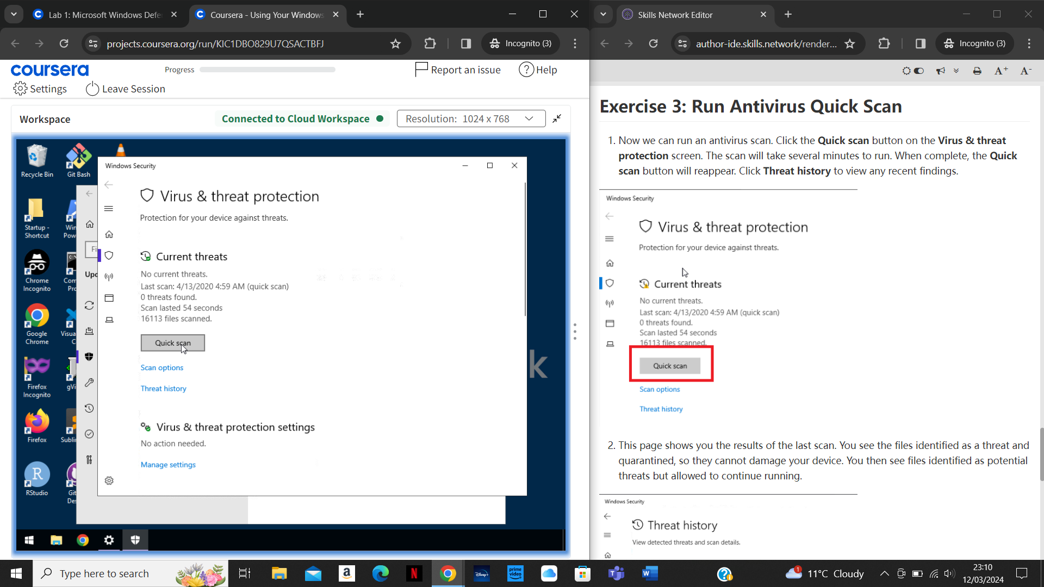

I navigated to the Virus and threat protection page again and clicked on ‘Quick scan’ under ‘Current threats’.

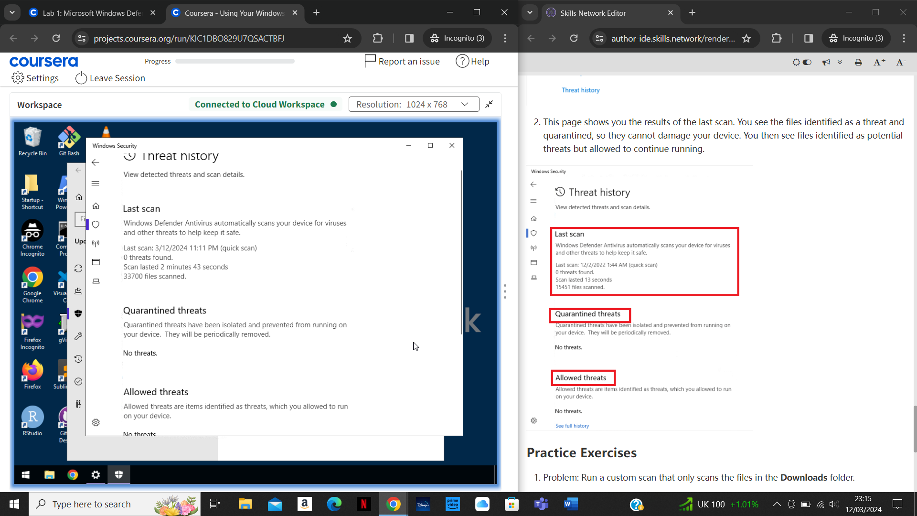

This gave me an output of any threats the scan had found including quarantined and allowed threats as well as information about the scan.

**Scanning for threats using a custom scan**

In order to complete a scan on specific files or folders I conducted a custom scan.

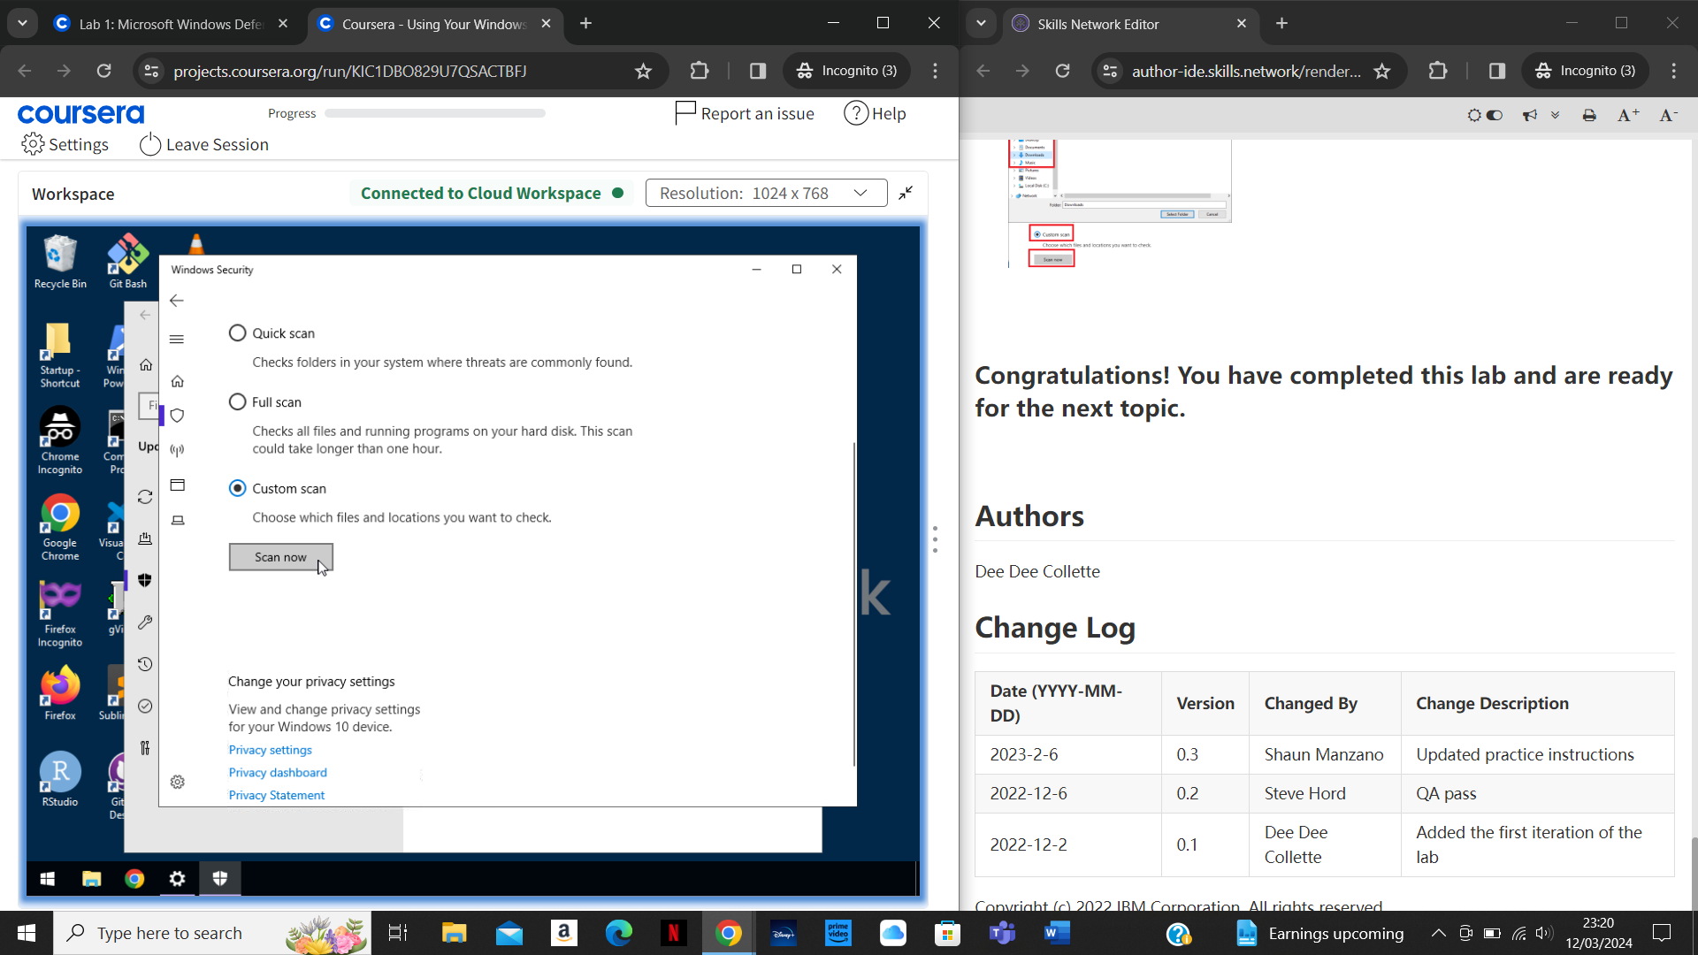

To do this I navigated to the Virus and threat protection page again and clicked on ‘Scan options’ instead of ‘Quick scan. Then I chose ‘Custom scan’ before selecting ‘Scan now’ as shown in the screenshots above.

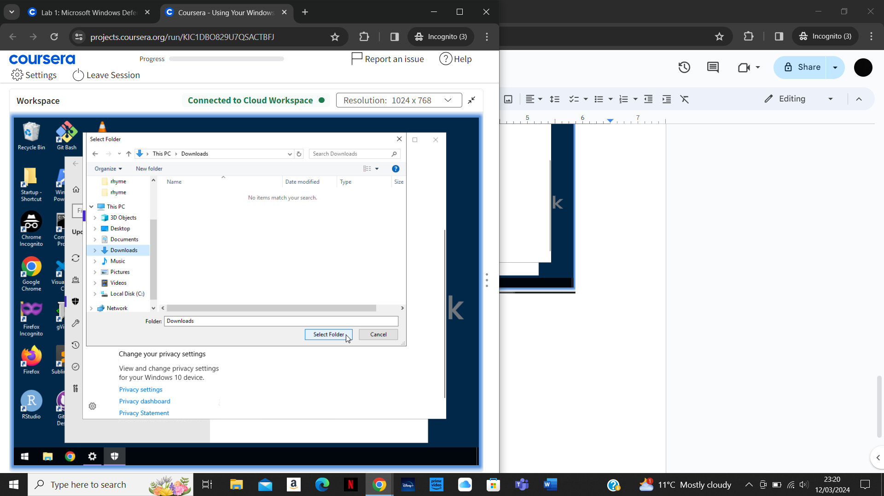

After this I was prompted to select a file or folder to scan as shown in the screenshot above. I selected the ‘Downloads’ folder and clicked on ‘Select Folder’. The scan then began on the downloads folder to check for threats. The output is shown below.

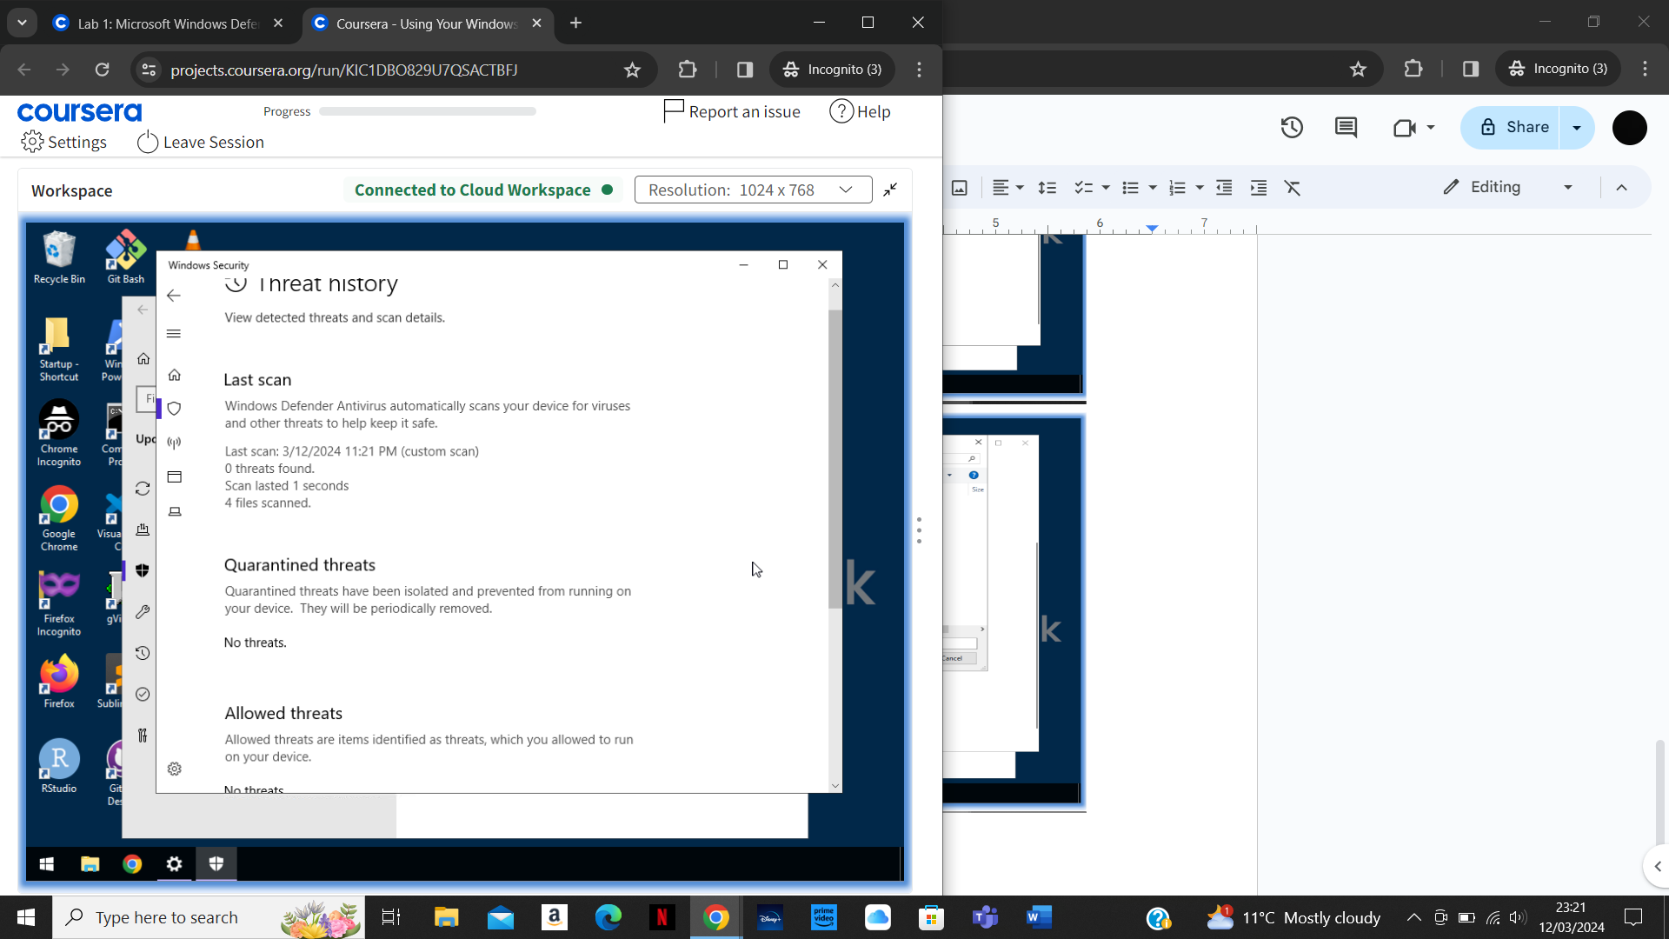

**Summary**

After completing this project I now know how to run antivirus scans on a computer using Microsoft Windows Defender. I also know how to scan specific files or folders if only certain items require scanning. Furthermore, I understand how to ensure the threat definitions are up to date with the latest information to establish a thorough scan of known threats.